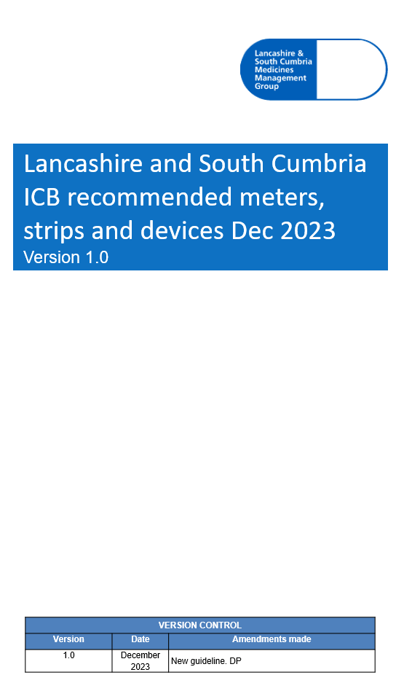

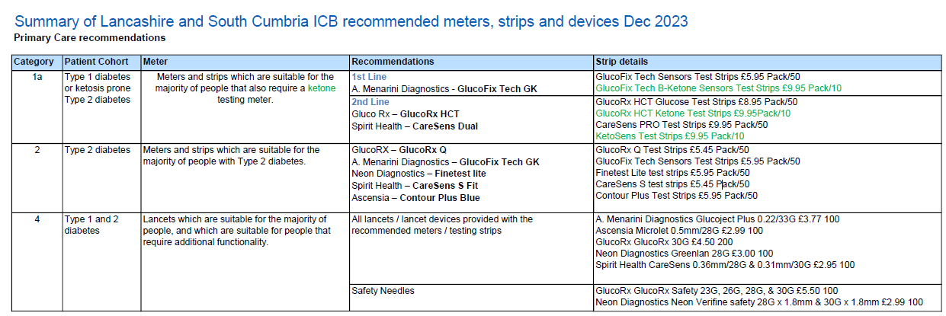
The meters have been selected based on the national recommendations along with existing preferences for placed-based teams. This will help: avoid unnecessary switches, reduce workload and maintain local supplies while at the same time ensuring cost effective choices.
Refer to NHSE Commissioning recommendations for blood glucose and ketone meters, testing strips and lancets (April 2023) additional options for specialist use e.g. in Paediatrics, Gestational diabetes and specific additional functionality.
https://www.england.nhs.uk/publication/commissioning-recommendations-blood-glucose-and-ketone-meters-testing-strips-and-lancets

